  - Project Name: AI Mechanic Assistant
- Week: 1
- Topic: Introduction to Mobile Development
- Date: 09/06/2026

Weekly Objectives
- Install and configure Android Studio development environment
- Create a basic Hello World mobile application
- Customize app title, background color, and font size
- Add button with click listener and Toast message
- Run application on emulator

Activities Completed
- Project Creation
Created a new Android Studio project named AIMechanicAssistant using:
- Template: Empty Views Activity
- Language: Kotlin
- Minimum SDK: API 24
- Layout Design
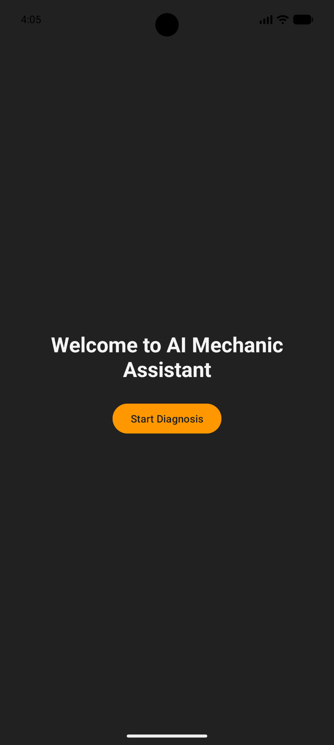
The running application displays:
- Custom welcome text at 28sp bold
- Start Diagnosis button with orange accent color
- Dark gray background representing automotive theme
- Emulator Testing
Created and ran Android Virtual Device (Pixel 9 pro API 33). App deployed successfully with custom automotive color scheme.

Challenges Faced
- Initial emulator setup required enabling hardware acceleration in BIOS
- Gradle sync took several minutes during first build
Solutions Implemented
- Enabled Intel HAXM for faster emulation
- Used offline Gradle dependencies for subsequent builds

WEEK 2
Weekly Objectives
- Implement Login and Registration screens
- Create Room database with VehicleEntity and Dao
- Build Vehicle list screen with RecyclerView
- Implement CRUD operations for vehicle management
- Test database persistence on emulator

Activities Completed
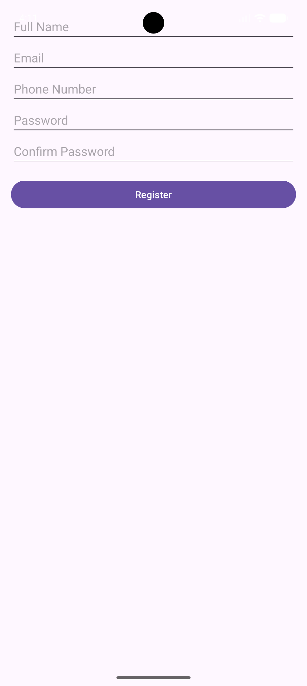
The registration screen includes:
- Full Name EditText
- Email EditText (textEmail inputType)
- Phone Number EditText
- Password EditText (textPassword inputType)
- Confirm Password EditText
- Register Button
4. Registration Screen with Keyboard
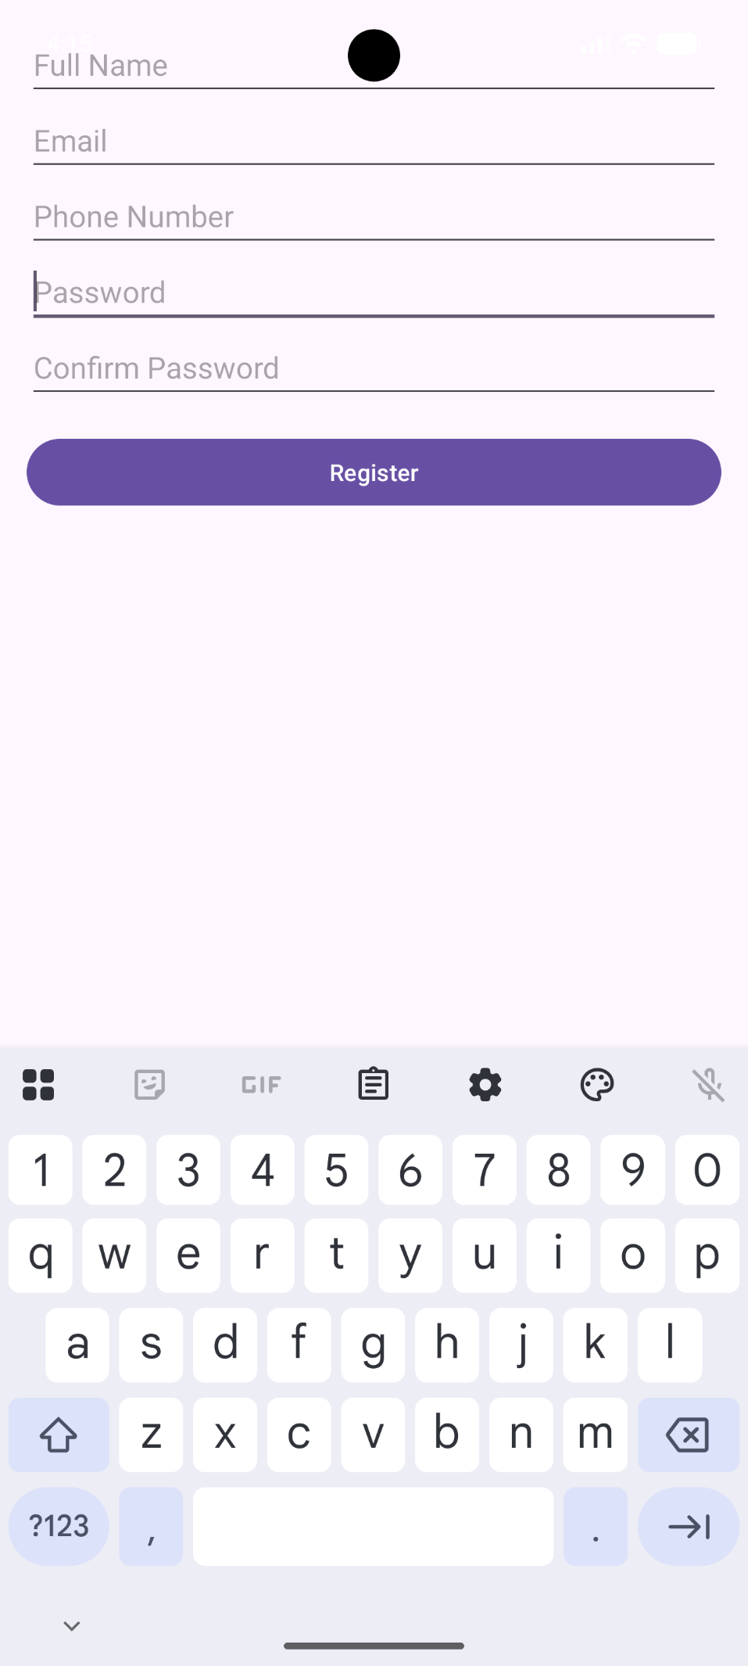
This demonstrates:
- Soft keyboard appearing on EditText focus
- Form validation active (password match checking)
- Responsive layout adjusting to keyboard
5. Room Database Implementation
Created the following database components:
- VehicleEntity – with properties: vehicleId, make, model, year, licensePlate, engineType, lastServiceDate, ownerUserId
- VehicleDao – Insert, Update, Delete, and Query methods
- VehicleDatabase – Singleton RoomDatabase instance
- DiagnosticRecordEntity – For storing AI diagnosis history
6. Vehicle List and Add Vehicle Screens
- Implemented VehicleListActivity with RecyclerView
- Created AddVehicleActivity with form fields for all vehicle properties
- Added navigation between Login, Register, Dashboard, and Vehicle screens

Challenges Faced
- Room database schema migration required careful version management
- KSP (Kotlin Symbol Processing) setup required additional plugin configuration
- RecyclerView adapter implementation required understanding of ViewHolder pattern
Solutions Implemented
- Used fallbackToDestructiveMigration() for development phase
- Added KSP plugin alias in libs.version.toml
- Created separate adapter class with proper ViewHolder pattern
WEEK 3 DOCUMENTATION
Weekly Objectives
- Design 7 XML layout files entirely within Android Studio (no external design tools)
- Create responsive layouts using Constraint Layout, Linear Layout, and weight distribution
- Implement custom automotive-themed colour scheme and typography
- Build navigation with BottomNavigationView and NavHostFragment
- Implement AI diagnosis logic with pattern matching for car symptoms
- Add gesture detection (swipe, double-tap, long-press)
- Implement maintenance reminders with notifications
- Test on physical device and tablet emulator

Activities Completed
1. XML Layout Files Created (7 Layouts)
2. Custom Colour Scheme (Automotive Theme)
Colour definitions created:
- primary colour – Deep blue (#1976D2) representing trust and reliability
- accent colour – Warning orange (#FF9800) representing check engine lights
- background colour – Dark grey (#121212) simulating a mechanic's garage
- surface colour – Light grey (#1E1E1E) for cards and surfaces
- error colour – Red (#F44336) for validation errors
- success colour – Green (#4CAF50) for successful diagnoses
- text_primary_colour – White (#FFFFFF) for readability
- text_secondary_colour – Light Grey (#B0B0B0) for hints and labels

3. Typography Styles
4. Main Dashboard Layout with Bottom Navigation
The dashboard includes:
- Welcome Card View displaying user name from Intent extra
- Statistics Card View with 3 metric cards using Linear Layout with equal weights
- BottomNavigationView with 3 destinations: Vehicles, AI Diagnosis, History
- Frame Layout as NavHostFragment container

5. Vehicle List Screen
Each vehicle card displays:
- Make and model (bold, headline1 style)
- Year and license plate (body2 style)
- Last service date with maintenance indicator
- Edit icon (pencil) and Delete icon (trash)

6. AI Diagnosis Screen
AI pattern matching implemented for:
- Battery/starting issues → "Dead battery or alternator failure" (85-95% confidence)
- Brake problems → "Brake pads worn or brake fluid low" (80-90% confidence)
- Engine codes (P0300, P0420) → "Engine misfire" or "Catalyst efficiency below threshold" (75-85% confidence)
- Overheating → "Coolant system issue or thermostat failure" (80% confidence)
- Transmission issues → "Transmission fluid low or solenoid failure" (70% confidence)
- Unusual noises (knocking, squealing) → Specific component diagnosis (75-90% confidence)
- Fluid leaks → "Oil leak from gasket" or "Coolant leak" (85% confidence)

7. Diagnostic History Screen
Filtering features:
- Spinner dropdown to filter by specific vehicle
- DateRangePicker to show diagnoses between selected start and end dates
- Export button to share history as text file

8. Settings Screen
Settings preferences:
- Default vehicle selection for quick diagnosis
- Dark mode toggle (AppCompatDelegate.setDefaultNightMode)
- Notification toggle for maintenance reminders
- Clear all history button with confirmation dialog
- Export all data button
9. Navigation Graph
The navigation graph defines:
- 3 top-level destinations (Vehicles, AI Diagnosis, History)
- 2 dialog destinations (AddVehicle, EditVehicle)
- Safe Args for passing vehicleId between fragments

10. Animation Files Created
Animations implemented:
- fade-in/fade-out – Fragment transitions
- slide up/slide down – Diagnosis result appearance
- shake – Edit Text validation error animation
- bounce – Button click feedback
11. Gesture Detection Implementation
Gestures implemented:
- Swipe right-to-left on AI diagnosis screen – Clears symptoms Edit Text and resets diagnosis result
- Double-tap on car engine Image View – Resets the entire diagnosis screen to default state
- Long-press on vehicle card – Opens bottom sheet with: Request Diagnosis, View History, Edit Vehicle, Delete Vehicle
- Long-press on diagnostic history item – Opens context menu with: Share via WhatsApp, Copy to Clipboard, Delete
- Swipe-to-delete on vehicle list – Deletes vehicle and associated diagnoses with undo Snack bar

12. Voice Input for Symptoms
Voice input features:
- Microphone button triggers Speech Recognizer
- Recognized speech automatically populates symptoms Edit Text
- Language support for English technical terms related to automotive issues

13. Maintenance Reminder Notifications
Reminder logic:
- Checks lastServiceDate of each vehicle
- Shows notification if last service > 6 months ago
- Shows notification if odometer reading > last service odometer by 5000km
- Notification channel created with importance HIGH
- Action buttons: Schedule Service (opens calendar), Remind Later (snooze for 1 week)

14. Physical Device Testing
Testing performed:
- USB debugging enabled on physical device
- Touch gestures tested (tap, long-press, swipe)
- Screen rotation tested – layout preserved using View Model
- Hardware back button tested – proper fragment back stack navigation
- Physical keyboard tested for form inputs

WEEK 4

ACTIVITES FOR THE WEEK
- Understand the data management
- Data base design
- Implementation activities
- Features designed and implanted which include:
- Add Vehicle screen
- Edit Vehicle screen
- Vehicle list screen
- Remove vehicle screen
- Tools and technologies used
- Android studio
- Kotlin
- SQlite
- Challenges faced
- Designing relationships between vehicles and repair records
- Managing database queries efficiently
- Solutions
- Used Room annotations to simplify database operations.
- Tested CRUD operations extensively using sample data.

SCREENSHOTS BASED ON THE WEEK’S WORK
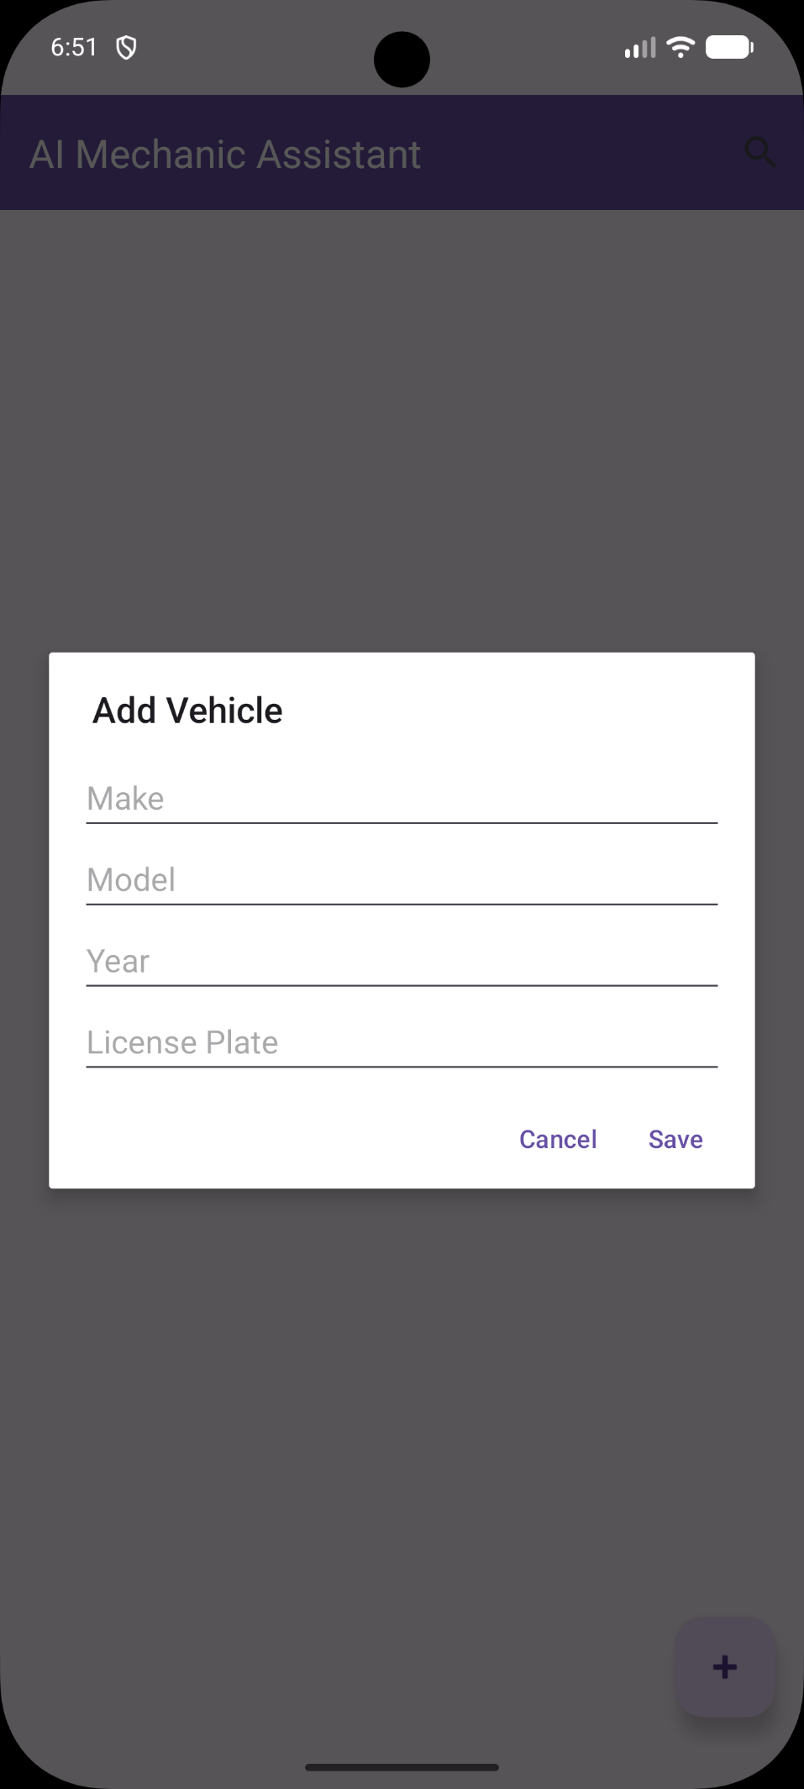
Based on this screenshot it previews the screen when you press the plus button which is on the bottom right which prompts you to add a vehicle make, model , year and its number plate

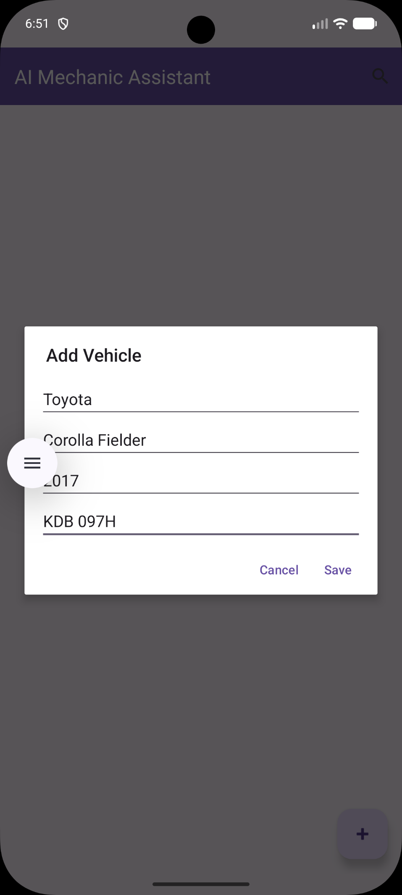

This screenshot displays when data is being entered into the system

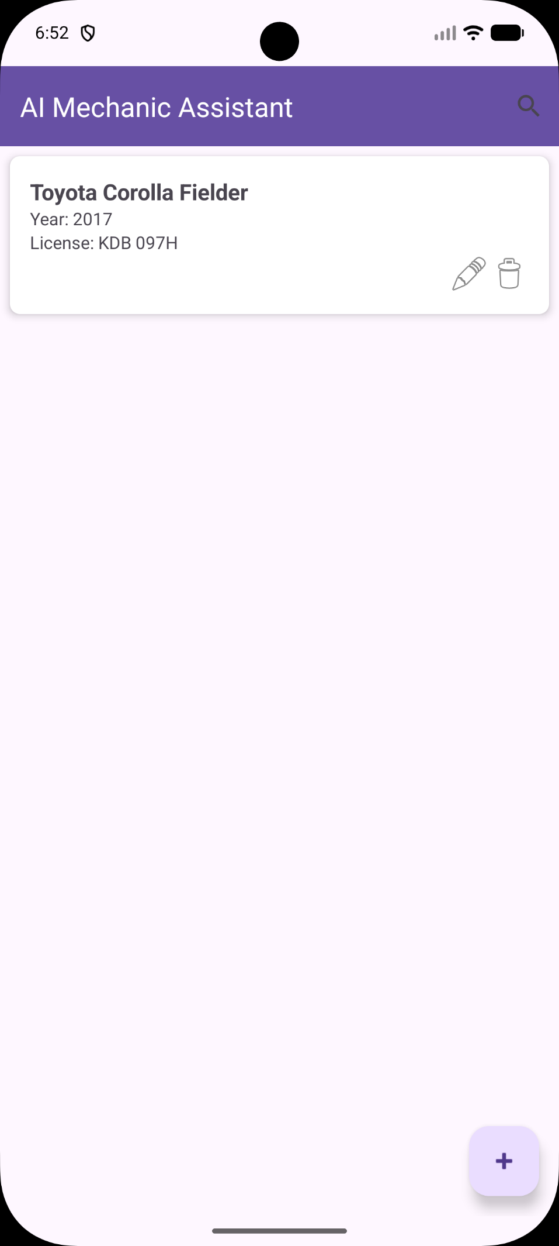

The screenshot above displays the data stored into the system in which it has no error

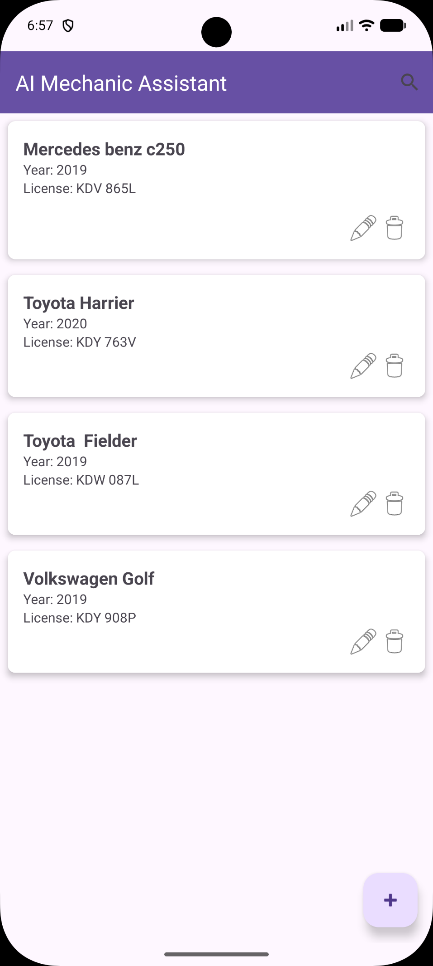
The screenshot above shows multiple data of multiple vehicles being stored into the system and into the data base

WEEK 5
Topic Covered
Networking and API Consumption

WEEK ACTIVITIES
- API researching and planning
- Networking implementation
- Features developed
- Fault Scanner module
- Fault code lookup functionality
- Repair recommendation screen
- API response display
- Error handling
Implemented handling for various errors such as
- Network timeouts
- Invalid responses
- Server errors (500)
- Unauthorized access (401)
- Missing resources (404)
- Tools and Technologies Used
- Retrofit
- Kotlin coroutines
- Challenges Encountered
- Understanding API documentation.
- Handling inconsistent API responses.
- Managing asynchronous operations.
- Solutions Applied
- Tested endpoints using Postman.
- Implemented proper exception handling.
SCREENSHOTS OF THE APPLICATION
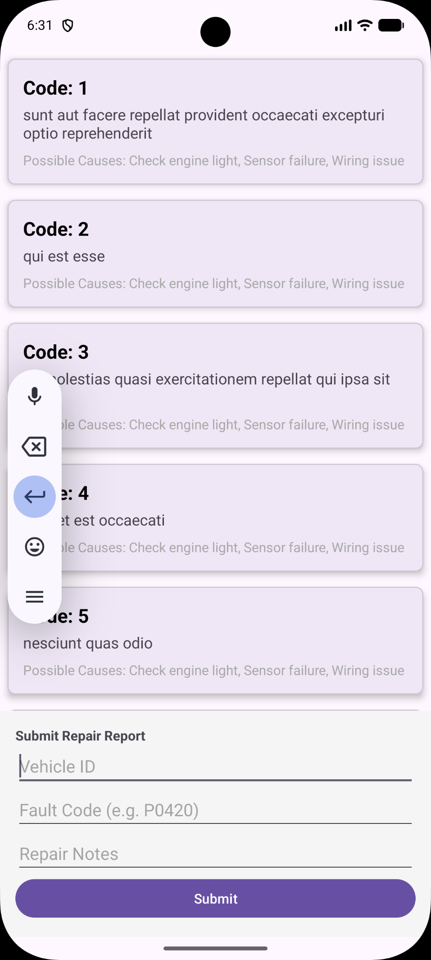

The screenshot above demonstrates the home screen of the app before entering any data to be uploaded

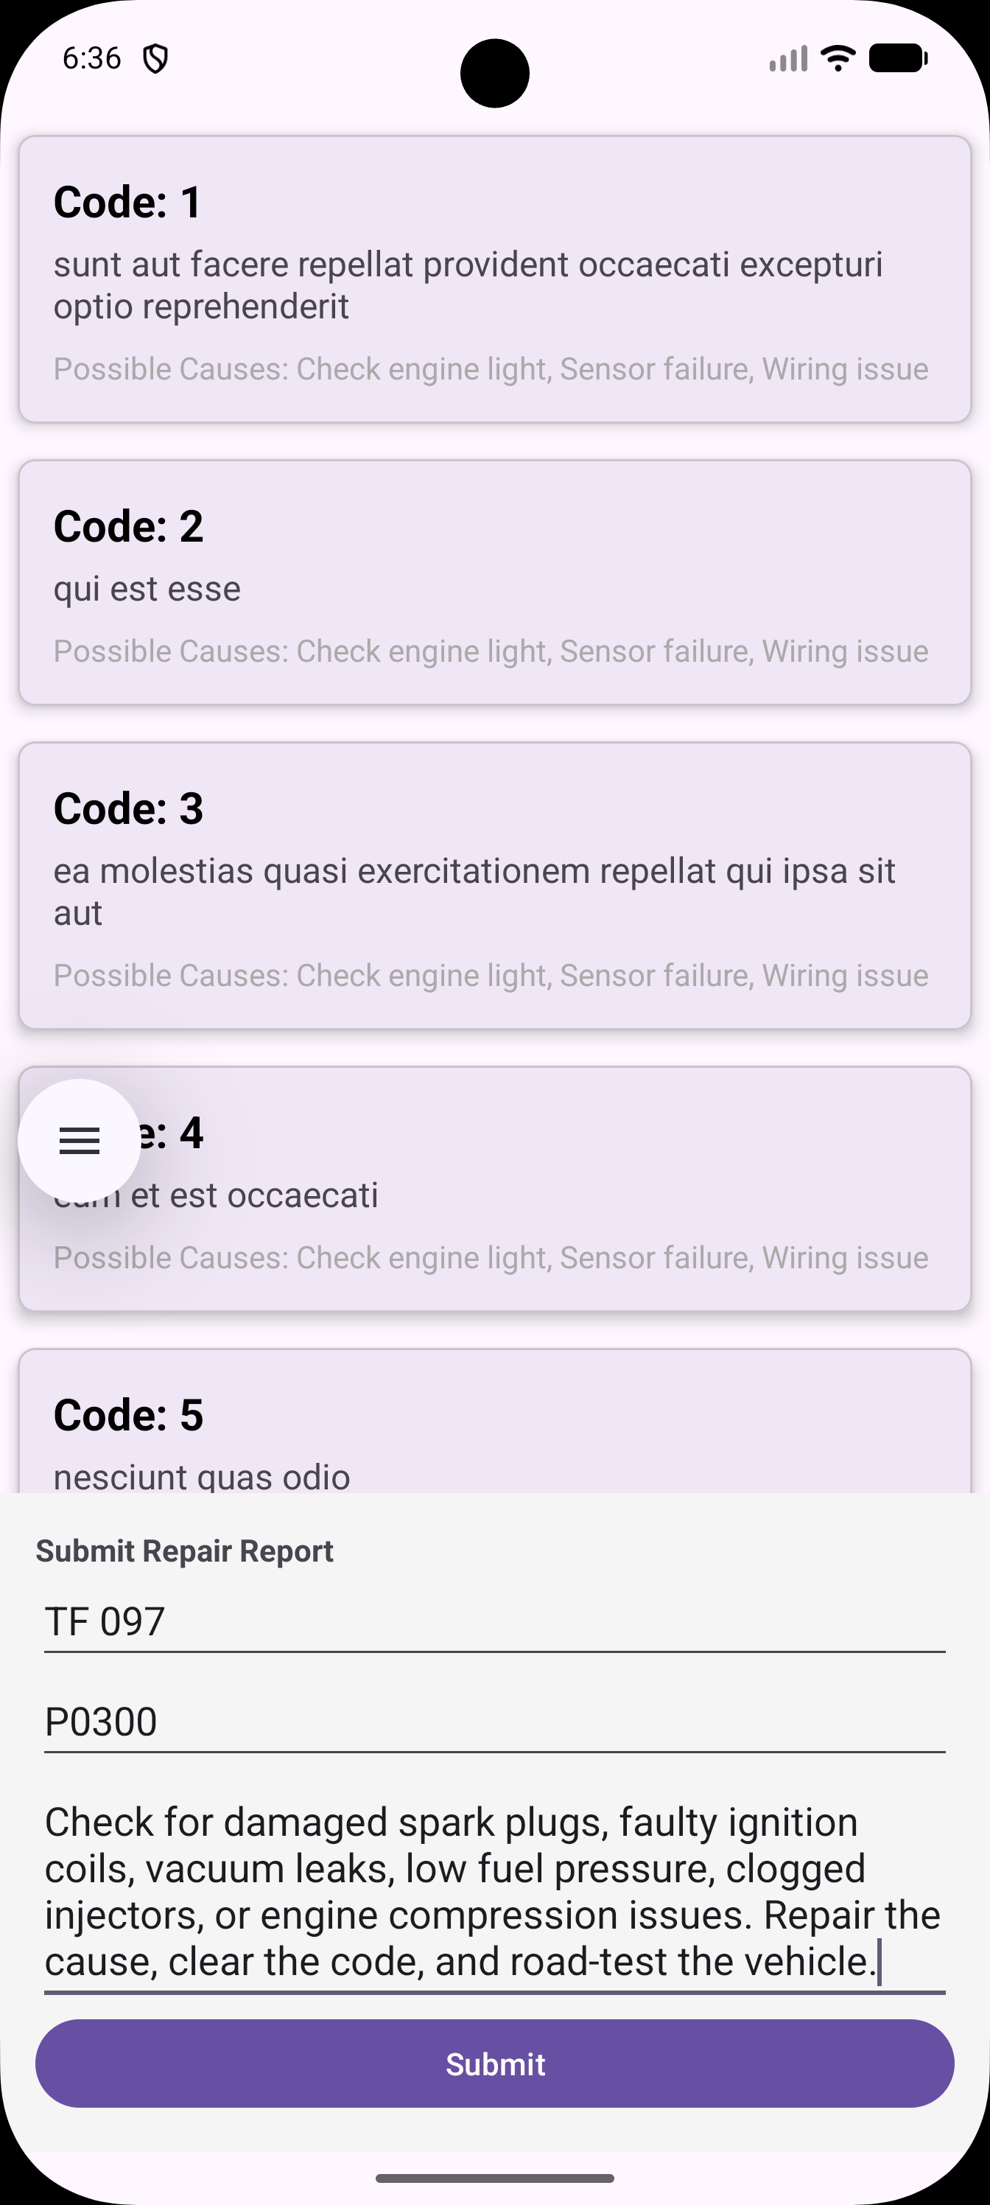
The screenshot above displays the system entering the repair report to the system so as to be accessed by the user this screen is mostly accessed by the administrator or the developer of the application and is used to manage the content which is being shown to the user and also the ai tool has access to this screen so as to integrate knowledge from the internet into the user interface

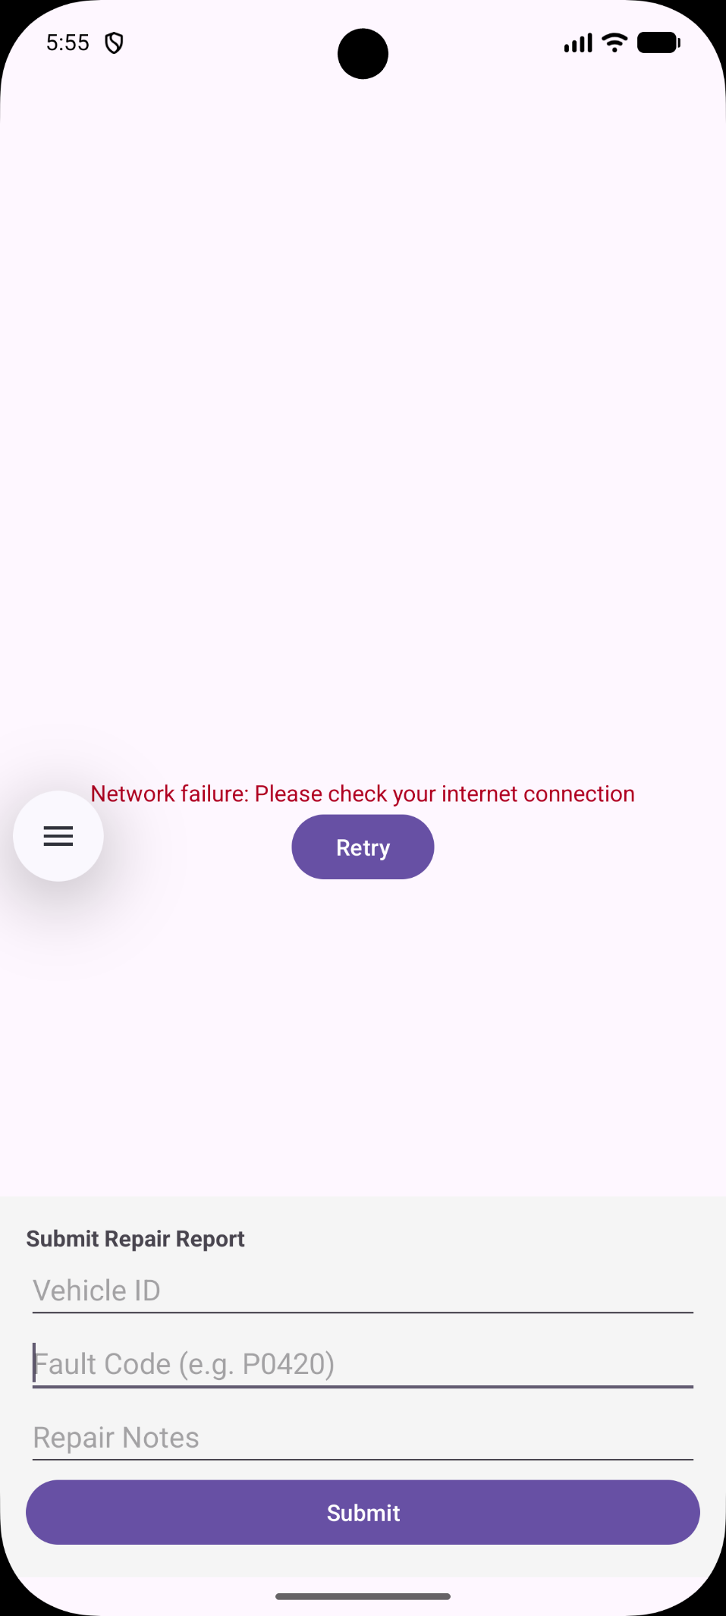

The screenshot above shows among the errors in which it shows if the app is not connected to the internet in which the error name is network timeout/failure and no information cannot be uploaded when there is this some sort of error

WEEK 6

TOOLS USED
- Android studio
- Kotlin programming language

WEEK OBJECTIVES/TASKS
- Collect all the tasks and progress from week 1
- Compile all the codes from week 1 to the current week
- Create a beta app showing all the features

SUMARATIVE FROM WEEK 1 WEEK 5
This week basically entails all the work that has been done from week 1 to the current week where all the tasks have been combined to make a beta version of the ai assistant mechanic tool
It starts from creating a user account up to keeping and displaying all the information to the user
